Create EC2 + Extend The Root EBS Volume online + Add Extra Volume + LVM Setup

Objective
Launch an EC2 instance, extend the root EBS volume, attach an extra EBS volume, and configure it using LVM (Logical Volume Manager).
Step 1: Launch EC2 Instance
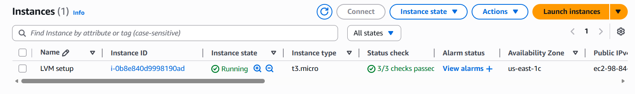

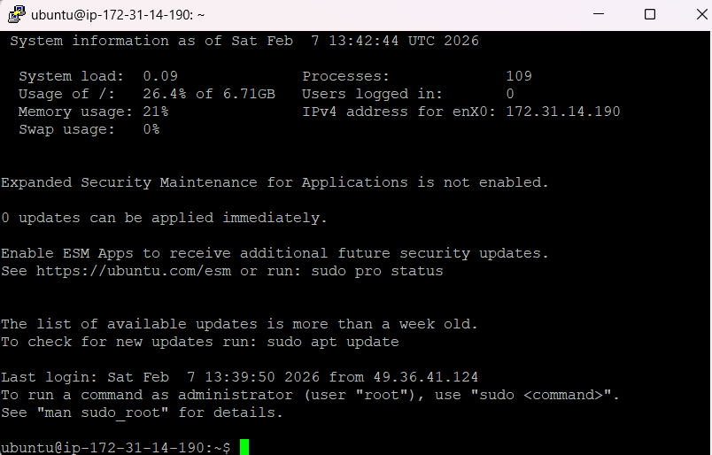
Step2-Connect using SSH:

3-

Step 3 - Create & Attach Extra EBS Volume
- EC2 → Volumes → Create Volume (e.g. 10GB)
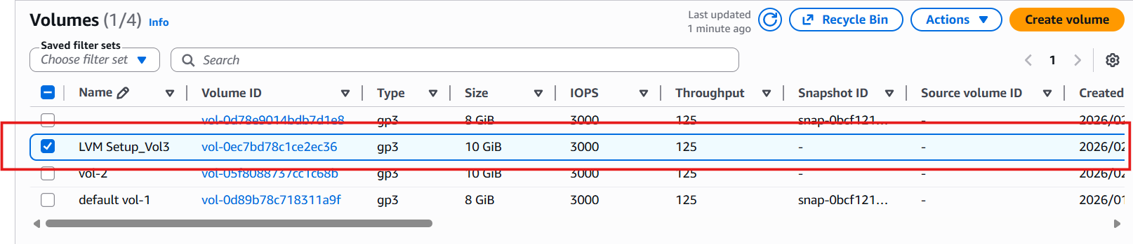

- Attach to instance
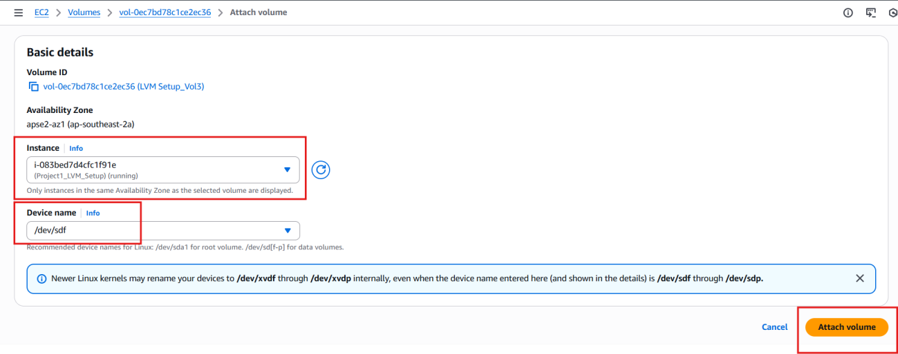
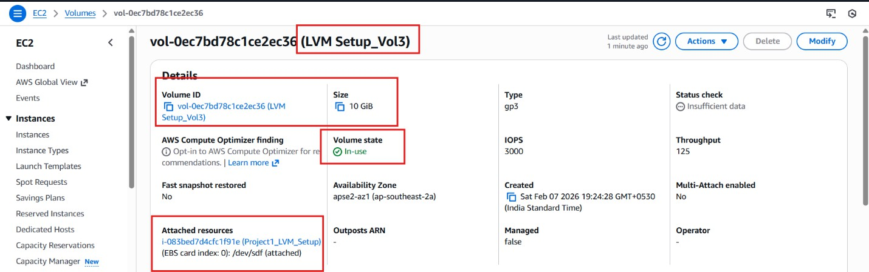

Step3 – Check the new volume (Disk) added or not. using below command.
- Check available disks
$ sudo su (switch to root)
# lsblk (list block devices for disks & partitions)
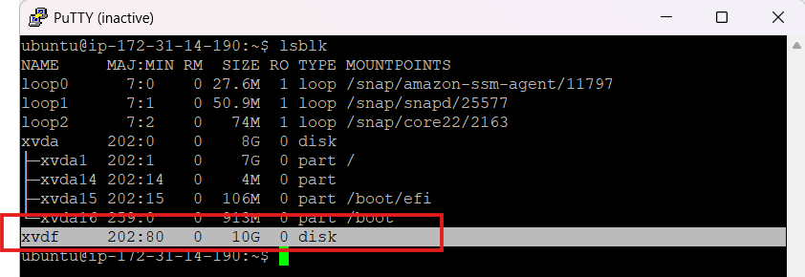
But if we see the disk are not mounted. check using below command.
#df -h disk free (human-readable)
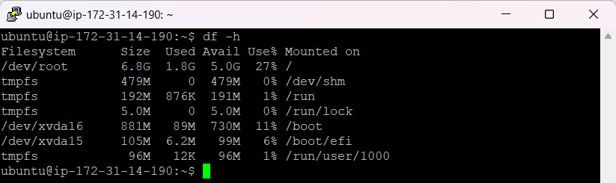
The newly added disk is not showing in this, so we need to create one directory at
/mnt/data (you can add anywhere) and mount it using below command.
- Create a mount directory
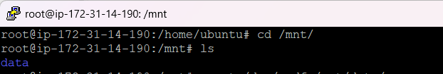

- Format disk (only if new disk)
. ı Skip if already formatted
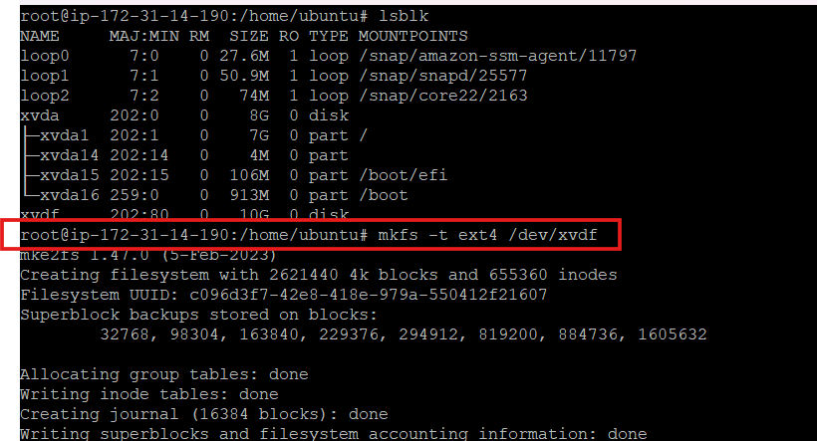

- Mount the disk
# mount /dev/xvdf mnt/data
- Verify mount
#df -h
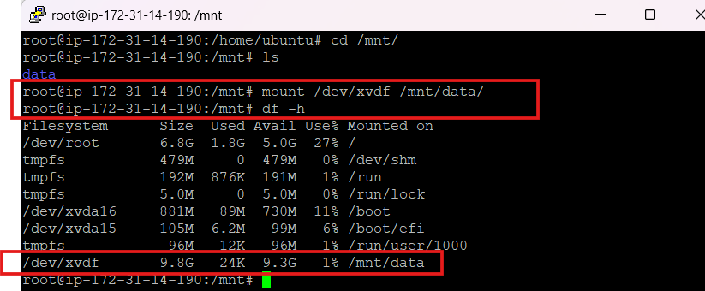

##MOST IMPORTANT POINT##
6- Permanent Mount Configuration (/etc/fstab ).
Purpose
The /etc/fstab file is used to define disk partitions and mount points that should be mounted automatically at system boot. It ensures that storage devices remain mounted even after a reboot.
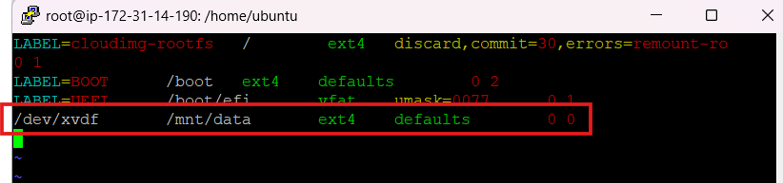
What happens if we do NOT put the entry in /etc/fstab? It will be mounted only for the current session. ##After a reboot:
- The disk will be unmounted
- The /data directory will be empty
- Your application or service using /data may fail
- You must mount it again manually every time
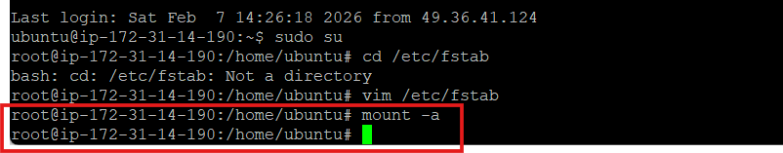
7- Check the entry is correct or not using below command. # mount -a

Note: If the /etc/fstab entry is correct then it will not be showing any error, if it showing error then correct the Fstab entry.

LVM Storage Challenge – Step by Step
Step 1: Check Current Storage
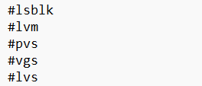
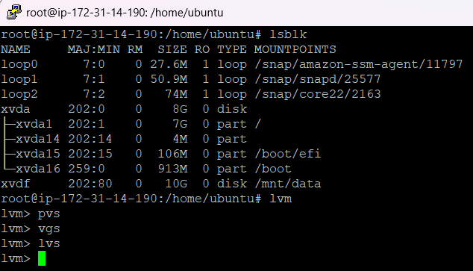
If there is no output that means not any lvm partition created. Step 2: create physical volume.
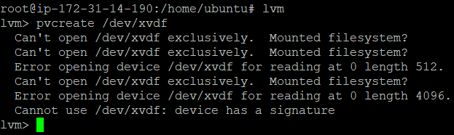
This error is showing Because, this error is actually protecting your data.
It means /dev/xvdf is already in use or already has a filesystem on it, so LVM refuses to overwrite it.
NOTE: So, we will create a new volume OR unmount /dev/xvdf disk using below command.
# unmount /dev/xvdf mnt/data
##Make sure remove the entry from /etc/fstab file also.

Step 3: Create one another volume and attached with current EC2 machine.
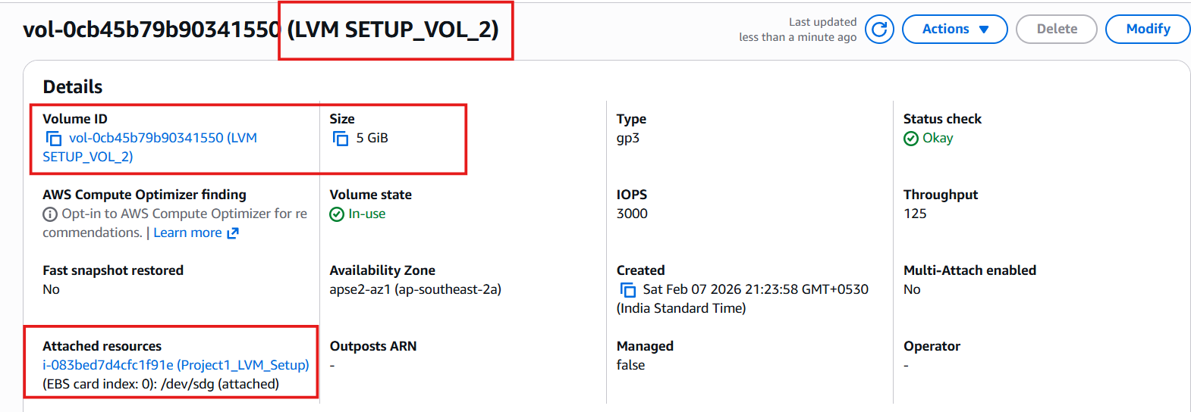
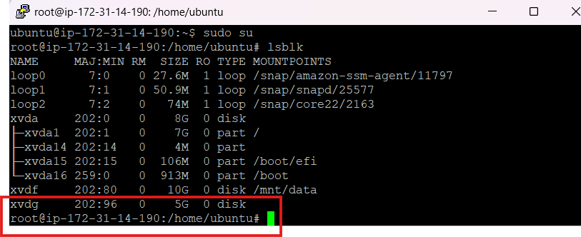

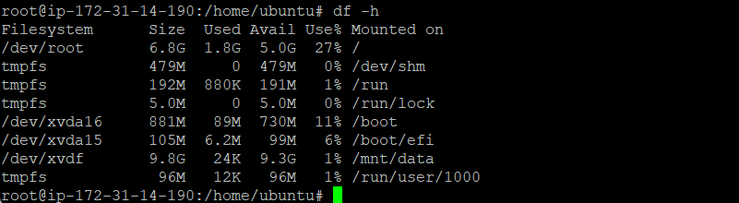
Its shows xvdg disk is not mounted. Now we can create LVM Partition.

1- Task 1: Check Current Storage
Run: lsblk, pvs, vgs, lvs, df -h
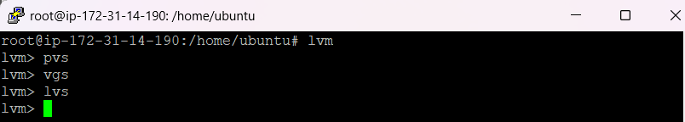

2: Create Physical Volume
# pvcreate /dev/xvdg
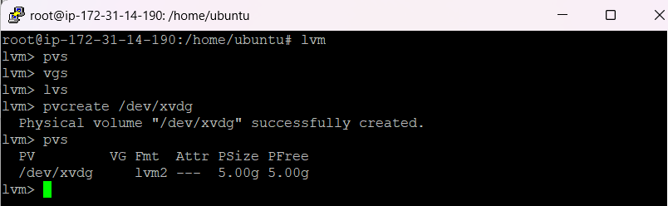

3: Create Volume Group
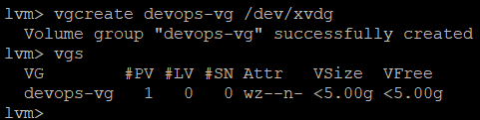

4: Create Logical Volume
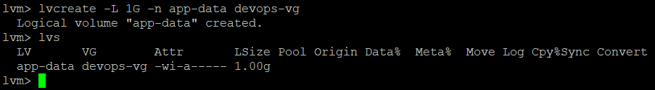

5: Format and Mount
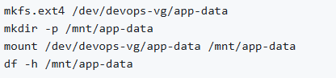
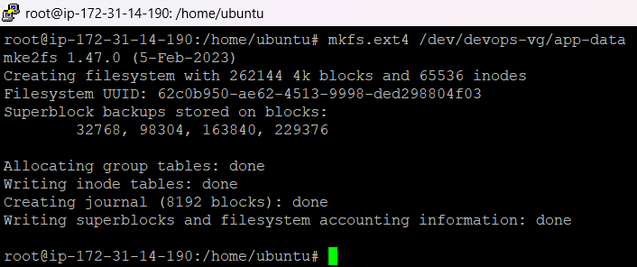
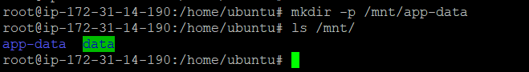
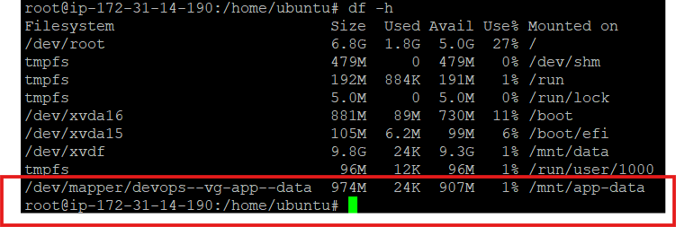

6: Extend the Volume
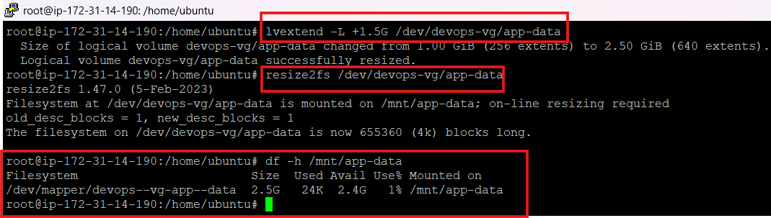

##What I learned Today.
- Adding new storage to a server
- Creating application data volumes
- Managing flexible storage
- Avoiding data loss
- Troubleshooting storage errors

##summary
- I configured LVM by creating a physical volume, volume group, and logical volume, then formatted and mounted it. I also learned how to troubleshoot common LVM errors like existing filesystem signatures and running system commands inside the LVM shell.

